**Bài số 4: DOM và XPATH**

1. Bài mẫu: Tạo file xml. Yêu cầu xây dựng form

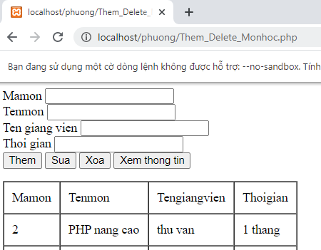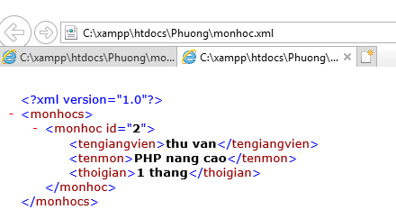

1. Code

<html> <body>

<form method="POST" action="Them_Delete_Monhoc.php">

Mamon <input type="text" name="ID"></br>

Tenmon <input type="text" name="Tenmon"></br>

Ten giang vien <input type="text" name="Tengv"></br>

Thoi gian <input type="text" name="Thoigian"></br>

<input type="submit" name="Add" value="Them">

<input type="submit" name="Update" value="Sua">

<input type="submit" name="Delete" value="Xoa">

<input type="submit" name="Xem" value="Xem thong tin"></form>

<?php

$xml=new SimpleXMLElement("monhoc.xml",null,true);

if(isset($_POST['Xem'])){

echo "<table border='1' cellspacing='0' cellpadding='10'>";

echo "<tr>";

echo "<td>Mamon</td>";

echo "<td>Tenmon</td>";

echo "<td>Tengiangvien</td>";

echo "<td>Thoigian</td>";

echo "</tr>";

foreach($xml as $mh){

echo "<tr>";

echo "<td>{$mh['id']}</td>";

echo "<td>{$mh->tenmon}</td>";

echo "<td>{$mh->tengiangvien}</td>";

echo "<td>{$mh->thoigian}</td>";

echo "</tr>";

}echo "</table>"; }

if(isset($_POST['Add'])){

$root=new DomDocument("1.0");

$root->load('monhoc.xml');

$id=$_POST['ID'];

$tenm=$_POST['Tenmon'];

$tengv=$_POST['Tengv'];

$thoigian=$_POST['Thoigian'];

$rootTag=$root->getElementsByTagName("monhocs")->item(0);

$infoTag=$root->createElement("monhoc");

$infoTag->setAttribute("id",$id);

$tengvTag=$root->createElement("tengiangvien",$tengv);

$tenmonTag=$root->createElement("tenmon",$tenm);

$thoigianTag=$root->createElement("thoigian",$thoigian);

$infoTag->appendChild($tengvTag);$infoTag->appendChild($tenmonTag);

$infoTag->appendChild($thoigianTag);$rootTag->appendChild($infoTag);

$root->save('monhoc.xml');}

if(isset($_POST['Update'])){

$root=new DomDocument("1.0");

$root->load('monhoc.xml');

$id=$_POST['ID']; $tenm=$_POST['Tenmon']; $tengv=$_POST['Tengv'];

$thoigian=$_POST['Thoigian']; $xpath=new DOMXPATH($root);

foreach($xpath->query("/monhocs/monhoc[@id=$id]")as $node){

//Tao node moi

$infoTag=$root->createElement("monhoc");

$infoTag->setAttribute("id",$id);

$tengvTag=$root->createElement("tengiangvien",$tengv);

$tenmonTag=$root->createElement("tenmon",$tenm);

$thoigianTag=$root->createElement("thoigian",$thoigian);

$infoTag->appendChild($tengvTag);

$infoTag->appendChild($tenmonTag);

$infoTag->appendChild($thoigianTag);

//thay the node moi vao node cu

$node->parentNode->replaceChild($infoTag,$node);

}

$root->save('monhoc.xml');

}

if(isset($_POST['Delete'])){

$root=new DomDocument("1.0");

$root->load('monhoc.xml'); $id=$_POST['ID']; $xpath=new DOMXPATH($root);

foreach($xpath->query("/monhocs/monhoc[@id=$id]")as $node){

$node->parentNode->removeChild($node);}

$root->formatoutput=true;$root->save('monhoc.xml');}

?></body></html>

Bài tập:

1. Tạo file xml như sau: Khachhang.xml
2. Viết code theo form và thực hiện các chức năng trong Form

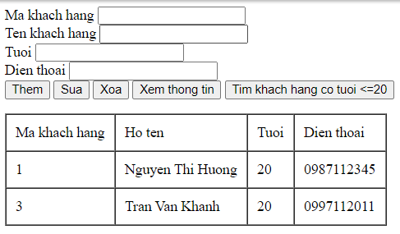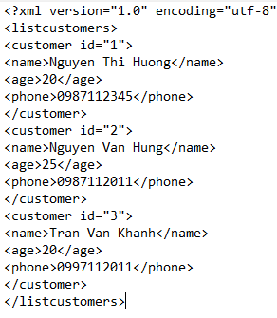

Code:

<html> <body>

<form method="POST" action="xulysv.php">Ma khach hang <input type="text" name="ID"></br>

Ten khach hang <input type="text" name="Tenkh"></br>

Tuoi <input type="text" name="Tuoi"></br>Dien thoai <input type="text" name="Dienthoai"></br>

<input type="submit" name="Add" value="Them"><input type="submit" name="Update" value="Sua">

<input type="submit" name="Delete" value="Xoa"><input type="submit" name="Xem" value="Xem thong tin">

<input type="submit" name="Search" value="Tim khach hang co tuoi <=20"> </form>

<?php

$xml=new SimpleXMLElement("Sinhvien.xml",null,true);

if(isset($_POST['Xem'])){

echo "<table border='1' cellspacing='0' cellpadding='10'>";

echo "<tr>"; echo "<td>Ma khach hang</td>";

echo "<td>Ho ten</td>"; echo "<td>Tuoi</td>"; echo "<td>Dien thoai</td>"; echo "</tr>";

foreach($xml as $sv){

echo "<tr>";

echo "<td>{$sv['id']}</td>";echo "<td>{$sv->name}</td>";

echo "<td>{$sv->age}</td>";echo "<td>{$sv->phone}</td>";

echo "</tr>";}echo "</table>"; }//code cho nút thêm

if(isset($_POST['Add'])){

$root=new DomDocument("1.0");

$root->load('Sinhvien.xml');

$id=$_POST['ID']; $tenkh=$_POST['Tenkh']; $tuoi=$_POST['Tuoi']; $phone=$_POST['Dienthoai'];

$rootTag=$root->getElementsByTagName("listcustomers")->item(0);

$infoTag=$root->createElement("customer");$infoTag->setAttribute("id",$id);

$tenkhTag=$root->createElement("name",$tenkh);$tuoiTag=$root->createElement("age",$tuoi);

$DienthoaiTag=$root->createElement("phone",$phone);

$infoTag->appendChild($tenkhTag);$infoTag->appendChild($tuoiTag);

$infoTag->appendChild($DienthoaiTag);$rootTag->appendChild($infoTag); //Tạo nút cho cây

$root->save('sinhvien.xml'); //lưu dữ liệu}

//Nút sửa

if(isset($_POST['Update'])){

$root=new DomDocument("1.0"); $root->load('Sinhvien.xml'); $id=$_POST['ID']; $tenkh=$_POST['Tenkh'];

$tuoi=$_POST['Tuoi']; $phone=$_POST['Dienthoai'];//tim den node goc

$xpath=new DOMXPATH($root);

foreach($xpath->query("/listcustomers/customer[@id=$id]")as $node){

//Tao node moi

$infoTag=$root->createElement("customer");$infoTag->setAttribute("id",$id);

$tenkhTag=$root->createElement("name",$tenkh);$tuoiTag=$root->createElement("age",$tuoi);

$DienthoaiTag=$root->createElement("phone",$phone);

$infoTag->appendChild($tenkhTag);$infoTag->appendChild($tuoiTag);

$infoTag->appendChild($DienthoaiTag);

//thay the node moi vao node cu $node->parentNode->replaceChild($infoTag,$node);}

$root->save('Sinhvien.xml');} //Nut xoa

if(isset($_POST['Delete'])){

$root=new DomDocument("1.0"); $root->load('Sinhvien.xml'); $id=$_POST['ID'];

$xpath=new DOMXPATH($root);

foreach($xpath->query("/listcustomers/customer[@id=$id]")as $node){

$node->parentNode->removeChild($node);}

$root->formatoutput=true;$root->save('Sinhvien.xml');}//Nut tim kiem

if(isset($_POST['Search'])) {echo "<table border='1' cellspacing='0' cellpadding='10'>";

echo "<tr>"; echo "<td>Ma khach hang</td>"; echo "<td>Ho ten</td>";

echo "<td>Tuoi</td>"; echo "<td>Dien thoai</td>";

echo "</tr>";

$result = $xml->xpath('/listcustomers/customer[age<=20]'); //điều kiện tìm kiếm

while(list( , $sv) = each($result)) {

echo "<tr>";echo "<td>{$sv['id']}</td>";echo "<td>{$sv->name}</td>";echo "<td>{$sv->age}</td>";

echo "<td>{$sv->phone}</td>";echo "</tr>";}echo "</table>";} ?></body></html>

Tìm kiếm cách 2:

foreach($xml as $kh){

if ($kh->age<25){

echo "<tr>";echo "<td>{$sv['id']}</td>";echo "<td>{$sv->name}</td>";echo "<td>{$sv->age}</td>";

echo "<td>{$sv->phone}</td>";echo "</tr>";}echo "</table>";}

}

}

Nút thêm xong load bảng luôn sửa như sau:

if(isset($_POST['Add'])){

$root=new DomDocument("1.0");

$root->load('Sinhvien.xml');

$id=$_POST['ID']; $tenkh=$_POST['Tenkh']; $tuoi=$_POST['Tuoi']; $phone=$_POST['Dienthoai'];

$rootTag=$root->getElementsByTagName("listcustomers")->item(0);

$infoTag=$root->createElement("customer");$infoTag->setAttribute("id",$id);

$tenkhTag=$root->createElement("name",$tenkh);$tuoiTag=$root->createElement("age",$tuoi);

$DienthoaiTag=$root->createElement("phone",$phone);

$infoTag->appendChild($tenkhTag);$infoTag->appendChild($tuoiTag);

$infoTag->appendChild($DienthoaiTag);$rootTag->appendChild($infoTag); //Tạo nút cho cây

$root->save('sinhvien.xml'); //lưu dữ liệu

$xml=new SimpleXMLElement("Sinhvien.xml",null,true);

echo "<table border='1' cellspacing='0' cellpadding='10'>";

echo "<tr>"; echo "<td>Ma khach hang</td>";

echo "<td>Ho ten</td>"; echo "<td>Tuoi</td>"; echo "<td>Dien thoai</td>"; echo "</tr>";

foreach($xml as $sv){

echo "<tr>";

echo "<td>{$sv['id']}</td>";echo "<td>{$sv->name}</td>";

echo "<td>{$sv->age}</td>";echo "<td>{$sv->phone}</td>";

echo "</tr>";}echo "</table>";

}